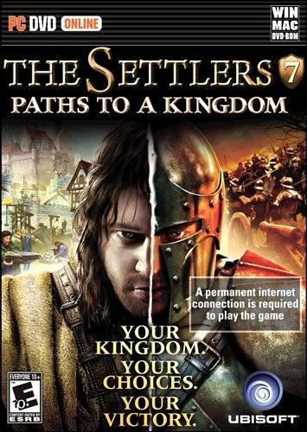

Understanding Civilization through Conquering One:
A Guide for Using The Settlers 7 to Teach 3rd Grade Social Studies

Written by
Mark Wright
National University
4/24/2011

Table of Contents
Teaching Guide Overview 3
The Settlers 7 Description 4
Using The Settlers 7 in the Classroom 5
The Advantages of Teaching with Games 6
Goals and Objectives 8
Grade Level Standards and Content Area 8
Where the Game fits into the Curriculum 10
What Teachers Need to Know Before Beginning 11
Hardware Requirements 11
Lessons Overview 12
Lesson One 13
Lesson One Goals and Objectives 13
Lesson One Setup 14
Lesson One Activity/Gameplay 15
Lesson One Follow-up/Debriefing 15
Lesson One Extensions 16
Lesson Two 16
Lesson Two Goals and Objectives 16
Lesson Two Setup 16
Lesson Two Activity/Gameplay 17
Lesson Two Follow-up/Debriefing 18
Lesson Two Extensions 18
Teacher Resources 19
References 20
Appendix A 21
Appendix B 22

Teaching Guide Overview
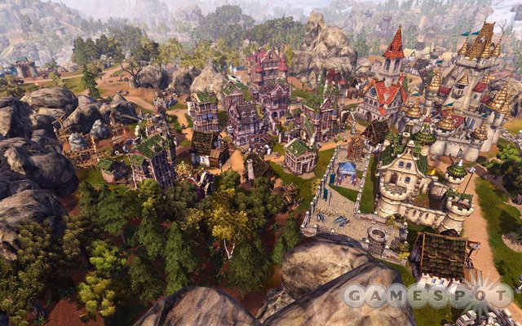
Ruling the world has many challenges. You can't make weapons without iron, and you can't smelt your iron without coal. What's a would-be world power to do? You could conquer all the neighboring communities and take their resources, you could master the art of trade and buy everything you need, or you could invest in science and learn to make do with what you have. Whatever choice you make there will be repercussions.
(Gamespot, 2010)
This Guide will help you engage your third grade students in a world outside their classroom in a way they have never been. Trying to teach them about the interdependence of nations and communities can be a challenge if they have never left their own neighborhoods. Trying to explain the consequences of government investment in science, trade, and the military can be difficult if they don't even have enough money to buy lunch. Using The Settlers 7 in the classroom gives students an opportunity to take control of a small government that must make choices to survive, and will help students to experience firsthand the long-term effects of these choices.

The Settlers 7 Description
The Settlers 7 is a real time strategy game released by Ubisoft in 2010. Available for both PC and Mac the game has three modes of game play: campaign that also doubles as the tutorial for the game, skirmish that allows players to compete with computer players on prebuilt maps, and online which allows players to compete with other players around the world.
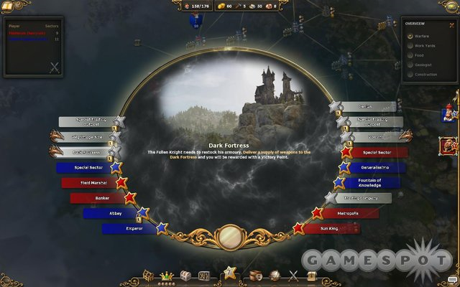
The game is built around the idea of accumulating "victory points" that can be gained from different types of play. There are three primary paths to achieving these victory points, and players must decide early in the game which path they will choose, be it military, trade, or science. When playing against the computer in campaign or skirmish mode, the player will face AI's (artificial intelligences) that specialize in using each of the different paths to victory. In addition to these specialties many AI's also have a secondary specialty in much the same way that a human player might choose to concentrate on a trade victory while building a strong military to defend his territory and expand his realm.
(Gamespot, 2010)
Despite the three separate paths to victory, all players must develop some internal and external trade in order to survive. In this way, the game naturally lends itself to a classroom discussion about interdependence. In addition, while the imaginary citizens will never revolt, they will complain about poor conditions and even stop working if proper trade and supplies are not provided.
Because The Settlers 7 requires a permanent internet connection to play, there are some interesting additions to the game as well. Ubisoft included some social networking features that allow players to update their Facebook pages with accomplishments. The game also connects directly to an online shop where players can buy and download extra in-game content. Additionally, players have the option of saving their games to the Ubisoft servers, and playing them from any location where the game has been installed.

Using The Settlers 7 in the Classroom
Students will have a chance to manage a civilization of their own. They will be in charge of deciding where the food comes from, what resources to use and how, where to make money, and the values inherent in their civilization. At each stage of game play, there are natural opportunities for discussion for teachers about the same kinds of choices being made in the real world.
Students will have an opportunity to relate classroom ideas to the ideas they have formed while playing the game. Relating these ideas to the real world can then be done through the use of idea webs, Venn diagrams, comparative essays, etc. Providing students with printable images from the game will also give them the opportunity to create visual representations of their ideas that can be placed alongside text to enhance engagement in written activities.

The Advantages of Teaching with Games
For most teachers who have spent years trying to develop lessons that were engaging enough to distract students from the increasingly interactive video games that they seem to play any time they are not in class, the idea of bringing those games into the classroom probably seems counterintuitive. However, Gee (2004) points out that high quality commercial games incorporate strong learning systems that are supported by cognitive research. The question then becomes, "How do we tap into those learning systems?"
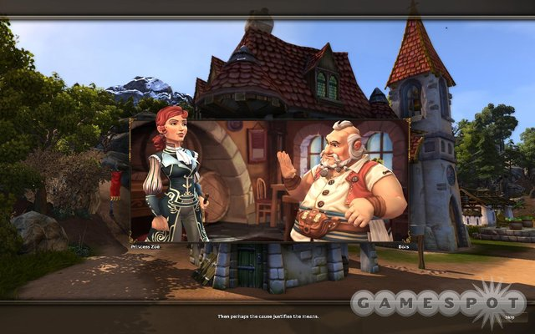
Gee (2004) goes on to point out that one of the most powerful systems used by good games to teach is the use of "just in time" information. By giving the player information just when they need it, and generating a situation where the player must apply that knowledge immediately, games support the transfer of that knowledge to long-term memory. Teachers using games in the classroom have an opportunity to piggyback this "just in time" learning by using the game to help students create a context for classroom learning. Students are able to take classroom learning and see how it can be applied in a simulated environment. This context can be enhanced further by providing an opportunity for students to compare the simulated environment with observations or discussions of the real world.
(Gamespot, 2010)
Another learning system in which games excel is the use of failure to increase engagement and contextual learning. Squire (2005) discusses how good video games present learners with complex problems that players must master before advancing. These problems are certain to cause repeated failure of the players as they learn to overcome each new problem. Players grow increasingly engaged as students increase their knowledge through recursive play (Squire, 2005). As Gee (2003) points out, games often push players to the limits of their ability, but always maintain their engagement by never pushing them beyond their capabilities. Educators have a real opportunity to differentiate instruction and increase motivation through the use of games that will automatically create an environment based on each players abilities.
With proper planning games have the ability to enhance almost any lesson style, though they are an ideal fit for teachers who utilize constructivist principles in their classroom. Many games provide an opportunity for students to be guided through their learning by virtual experts that fit the description of cognitive experts as described by Falance (2001). In this way students are provided with support by experiencing how the experts learn and solve problems. As technology continues to grow, students can now collaborate not only with digital experts, but real experts worldwide throught the use of the networking features of many games.
Using games in the classroom provides teachers with a safe, engaging, contextually rich opportunity to help students to experience learning in environments that they may not ever have access to in the real world.

Goals and Objectives
Upon completion of this lesson, students will be able to:
- Define scarcity as people wanting more things than are available, and give examples in a written explanation of an interdependence web.
- Explain how scarcity affects the way people produce, distribute, and consume goods and services by creating an interdependence web of their community and comparing it to their interdependence web from game play.
- Demonstrate how scarcity makes people and communities depend on each other by creating an interdependence web based on The Settlers 7.
- Compare the effects of different decisions about the community on its success by creating a visual representation of the decisions they make during game play and comparing it with other players.
- Develop a process to identify a problem or need for a decision, consider options, implement a solution, and evaluate effectiveness and represent that process visually.

Grade Level Standards and Content Area
This guide addresses the following Texas State Content Standards for third grade social studies students:
Standard 7: Economics. The student understands the concept of an economic system. The student is expected to:
  - define and identify examples of scarcity;
  - explain the impact of scarcity on the production, distribution, and consumption of goods and services;
  - explain the impact of scarcity on interdependence within and among communities

Standard 16: Social studies skills. The student applies critical-thinking skills to organize and use information acquired from a variety of sources including electronic technology. The student is expected to:
  - obtain information, including historical and geographic data about the community, using a variety of print, oral, visual, and computer sources
  - sequence and categorize information
  - interpret oral, visual, and print material by identifying the main idea, identifying cause and effect, and comparing and contrasting
Standard 17: Social studies skills. The student communicates effectively in written, oral, and visual forms. The student is expected to:
  - express ideas orally based on knowledge and experiences;
  - create written and visual material such as stories, poems, pictures, maps, and graphic organizers to express ideas; and
  - use standard grammar, spelling, sentence structure, and punctuation.
Standard 18: Social studies skills. The student uses problem-solving and decision-making skills, working independently and with others, in a variety of settings. The student is expected to:
  - use a problem-solving process to identify a problem, gather information, list and consider options, consider advantages and disadvantages, choose and implement a solution, and evaluate the effectiveness of the solution;
  - use a decision-making process to identify a situation that requires a decision, gather information, identify options, predict consequences, and take action to implement a decision.

Where the Game fits into the Curriculum
This game guide is designed to help students to develop an increased understanding of the economic underpinnings of society, why choices must be made, and how those choices affect the society as a whole. In order for students to begin to discuss these ideas they should already have a fundamental grasp of how communities are formed, and what roles individuals and groups have in forming and running a community. This lesson will also require the ability to understand and use some academic vocabulary outside the game environment including:
- consumer
- distribution
- economy
- goods
- interdependence
- producer
- services
- trade

What Teachers Need to Know Before Beginning
Before implementing this game in the classroom, the teacher should be familiar with the components of the games, and some of the basic decision based concepts of the game. It is recommended that the teacher complete at least the first several units of the "campaign" mode of the game, which will familiarize him/her with how the game is played, and how decisions affect outcome.

Teachers should also be aware of the social components of the game, and have a plan for either making use of those components constructively, or ensuring they are not used by the students, in order to avoid distractions unrelated to the lesson. For each lesson, teachers will need a minimum of one computer for every four students, while ideally having one computer for every two students for lesson one.

Hardware Requirements
Minimum System Requirements for PC Game – The Settlers 7: Paths to a Kingdom
- OS: Windows XP, Vista or Windows 7
- CPU: 2 GHz Intel Pentium 4 / AMD XP 2600+ or better
- RAM: 2 GB
- HDD: 8 GB free disk space
- Graphics: 256 MB Graphics Memory with Shader 3.0
- Sound Card: DirectX 9 Compatible
- DirectX: Version 9.0c
- Internet Connection: Broadband Internet connection with 128 kbps upstream or faster.
Mac Minimum system requirements for The Settlers 7: Paths to a Kingdom
- OS: OS K 10.6.3 Snow Leopard or higher
- Processor: Intel Duo Core (Intel 2 Duo Core)
- Memory: 2 GB (Recommended 4 GB)
- Hard Drive: 8 GB free Hard Disk space
- Video Card (graphics): 256 MB RAM (Recommended 512 MB RAM)
- Single player: 33.6kbit/s upstream (33.6kbit/s upstream)
- Mulitplayer: 128 kbit/s upstream (128 kbit/s upstream)

Lessons Overview
These lessons will be completed over approximately four class periods, based on a 45-minute class period, and the expectation of course related homework/groupwork. The first lesson will focus primarily on an understanding of scarcity and interdependence. This can be done through playing the first few levels of the campaign mode of the game, which also works to teach students how to play the game. In this way, students can accomplish the goal of learning the game, and lesson objectives at the same time. Teachers should remain available to answer questions and help with game play, especially early in the game to ensure students are able to progress quickly enough to focus on the lesson.
Students should work in pairs, to create the opportunity for discussion and decision making, though the lesson can also work with larger groups. Students should have simple questions to answer to keep them on the task of thinking about the lesson, without being overly distracting. During game play, teachers should be circulating amongst the players asking questions about resources, trade, and community growth to ensure students keep the idea of interdependence active throughout the lesson. Teachers should remember, however, that this game is played in real-time, and excessive pauses, like those often caused by large groups and extensive conversation, can negatively impact game play. Each student should be given an opportunity to be player and scribe, so that they can experience the role of decision maker in the game.

Lesson One
As students begin the quest for dominance in the campaign mode of the game, they will develop some fundamental skills necessary for game play. Since the idea of scarcity and interdependence is central to how the game is played, this idea will be repeated through each level, providing an opportunity for students to recognize and understand how important it is to the game. This provides the teacher an opportunity to compare the games fundamental principles of the necessity of trade with real-world civilizations.

Lesson One Goals and Objectives
Upon completion of this lesson, students will be able to:
    - Define scarcity as people wanting more things than are available, and give examples in a written explanation of an interdependence web.
    - Explain how scarcity affects the way people produce, distribute, and consume goods and services by creating an interdependence web of their community and comparing it to their interdependence web from game play.
    - Demonstrate how scarcity makes people and communities depend on each other by creating an interdependence web based on The Settlers 7.

Lesson One Setup
The teacher should ensure that students have a basic grasp of the vocabulary of scarcity and interdependence (see section, “Where the Game Fits into the Curriculum”). Teachers should also demonstrate to students how to construct an interdependence web, and instructions on how to gather the information needed to create their own from game play. A simplified interdependence web based on The Settlers 7 has been included as Appendix B. Students that are performing the task of scribe should have questions provided to them that help them understand how the resources from different communities are needed in order to produce goods. For instance, players who decide to create their own coins during the game must find a gold mine. When creating a mint to turn the gold into coin, students will discover that the mint requires both gold and coal. If the community they control does not have coal, then they must find a way to trade for it. Teachers will need to be available during play to ensure students are obtaining the information from the game.

Lesson One Activity/Gameplay
Each pair should decide who will be the player, and who will keep notes during the game. Students should rotate approximately every 15 minutes, providing time for students to play each role.
    - From the main menu, students should select "Campaign" from the "Play" menu.
    - Students will be able to watch and read the story setup, after which they will be brought to their first map to begin play.
    - Students should follow the onscreen instructions to begin play and try to win their first scenario according to the provided guidelines.
    - One student should be acting as scribe to record items that must be traded between communities in order for the civilization to function properly.

Lesson One Follow-up/Debriefing
After students have gathered enough data/play time on the game, they should work in their pairs to create an interdependence web from the game. Students should be provided images or access to images from the game, as well as the opportunity to create images if they prefer. Students should create a more formal description of their findings from the game that can be presented with their interdependence web.

Lesson One Extensions
Students should research at home or the library to find how their community, state, or nation is interdependent with others, and create an interdependence web. Students can then create a side-by-side presentation using the interdependence web from the game, and the interdependence web from the real world. As a final assessment, students should write a paragraph comparing and contrasting the ideas they learned about the real world with those discovered in game.

Lesson Two
This lesson is designed to enhance problem solving, team building skills, and evaluation strategies. This lesson can be used as a follow up to the earlier lesson, or can be used later in the curriculum as a way to help students better understand how to work through a hypothesis on their own.

Lesson Two Goals and Objectives
At the completion of this lesson, the student will be able to:
- Use a problem-solving process to identify a problem, gather information, list and consider options, consider advantages and disadvantages, choose and implement a solution, and evaluate the effectiveness of the solution.

Lesson Two Setup
Because this lesson is a follow up to the original lesson, teachers should not need to help students understand basic game play. Also, this lesson is a skills based lesson, not a content lesson, so any vocabulary that is necessary will come from the content being taught when this lesson is implemented. An example problem solving process is provided in Appendix A for demonstration with the students. Students may use this strategy or a different one, as long as they can demonstrate all of the steps in the solution finding process.

Lesson Two Activity/Gameplay
In this lesson, students will be playing in skirmish mode. Unlike campaign mode, the objective is to collect a certain number of victory points as assigned by each different map. Students must select a map, select opponents based on chosen relative strengths, and then select a strategy -- military, trade, or science -- as their primary victory path. Students should work in groups of four and should discuss points of strategy using their chosen problem-solving process.
      - From the main menu, students should select "Skirmish" from the "Play" menu.
      - Students should select a 2, 3, or 4 player map depending on how much time is allotted for the lesson. Teachers should be aware that the larger the map, the longer the play.
      - Students can then select their opponent(s). Each AI has different preferred victory methods, which are represented by crossed swords (military), a globe (trade), and a scroll with a cross (science). Some AI's have a primary and secondary preference.
      - Students can enter the game. They will begin with one community, a tavern (for recruiting an early army), a builder, and possibly a couple of homes depending on the chosen map. At this point they must decide what to build, what to conquer, and what to study.

Lesson Two Follow-up/Debriefing
If students are using the "Problem/Solution" outline during game play, they should discuss the results, and recreate their outlines in larger more creative scale. Students using a different method of data collection need to create a visible representation of the decision making process. Once complete, students in their groups should post their outlines, and the class should complete a gallery walk. Teachers should then discuss with students some of the best solutions, and the advantages and disadvantages to having different points of view for community problem solving.

Lesson Two Extensions
Have students write about what they might have done differently if they had been playing alone, instead of with a group. What different choices would they have made? Would they have been more or less successful? Would they make the same choices now, given what they know?

Teacher Resources
Gamespot
A website with a huge array of images from the game, as well as a review and some basics of game play.
Official Settlers 7 Website
The official Ubisoft site for this game, including instructions, links to fansites, trailers, and lots of goodies that kids might like to have access to.

References

Falance, T. (2001). Constructivism. In K. L. Medsker, & K. A. Holdsworth (Eds.), Models and Strategies for Training Design (pp. 213-234). Silver Spring: International Society for Performance Improvement.
Gamespot. (2010, April 4). Gamespot. Retrieved April 8, 2011, from Gamespot: http://www.gamespot.com/pc/strategy/thesettlers7pathstoakingdom/images.html?tag=tabs%3Bimages
Gee, J. P. (2003, May). High Score Education. Retrieved April 2011, from Wired.com: http://www.wired.com/wired/archive/11.05/view.html?pg=1
Gee, J. P. (2004). What Video Games Have to Teach Us about Learning and Literacy. Retrieved April 2011, from university of Technology Sydney: https://learn.it.uts.edu.au/31002/Autumn04/support/learnfromgames.pdf
Squire, K. (2005). Changing the Game: What Happens When Video Games Enter the Classroom? Retrieved April 2011, from Innovate Online: http://www.innovateonline.info/index.php?view=article&id=82

Appendix A

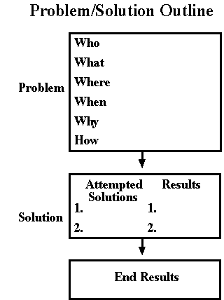

Appendix B

This interdependence web is a simplified version of what a teacher might expect from a student. In a final project, students should be expected to include images and utilize three dimensional craft supplies (i.e. string, realia, models, etc) to produce a more sophisticated web.

